Users Type in the Application

**1. Admin**

**2. User**

**Admin**

Here Admin have the different accessible right who can manage complete application

Modules

**1. Login**

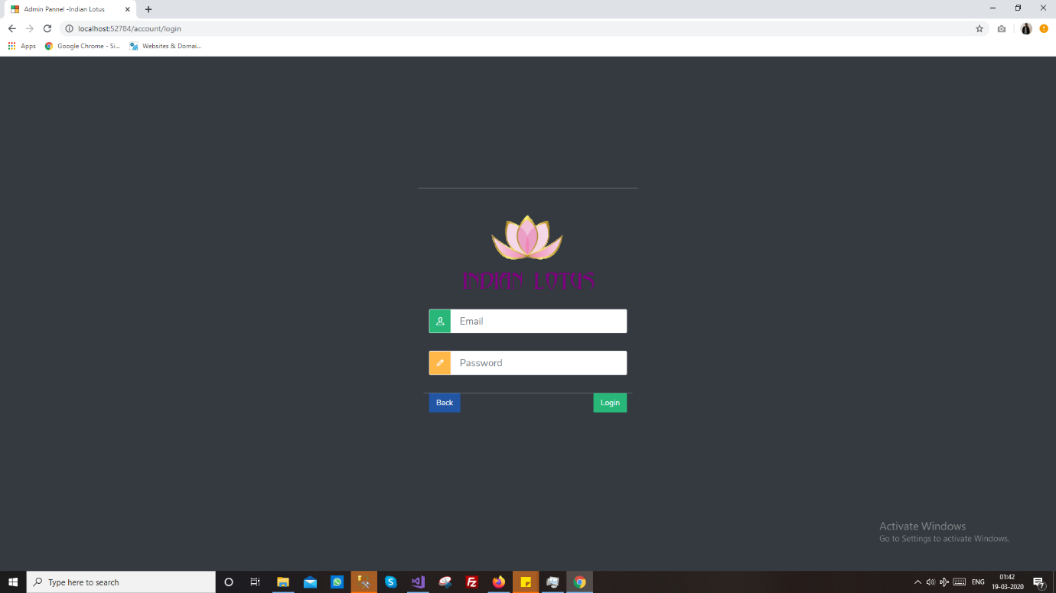

**2. Dashboard**

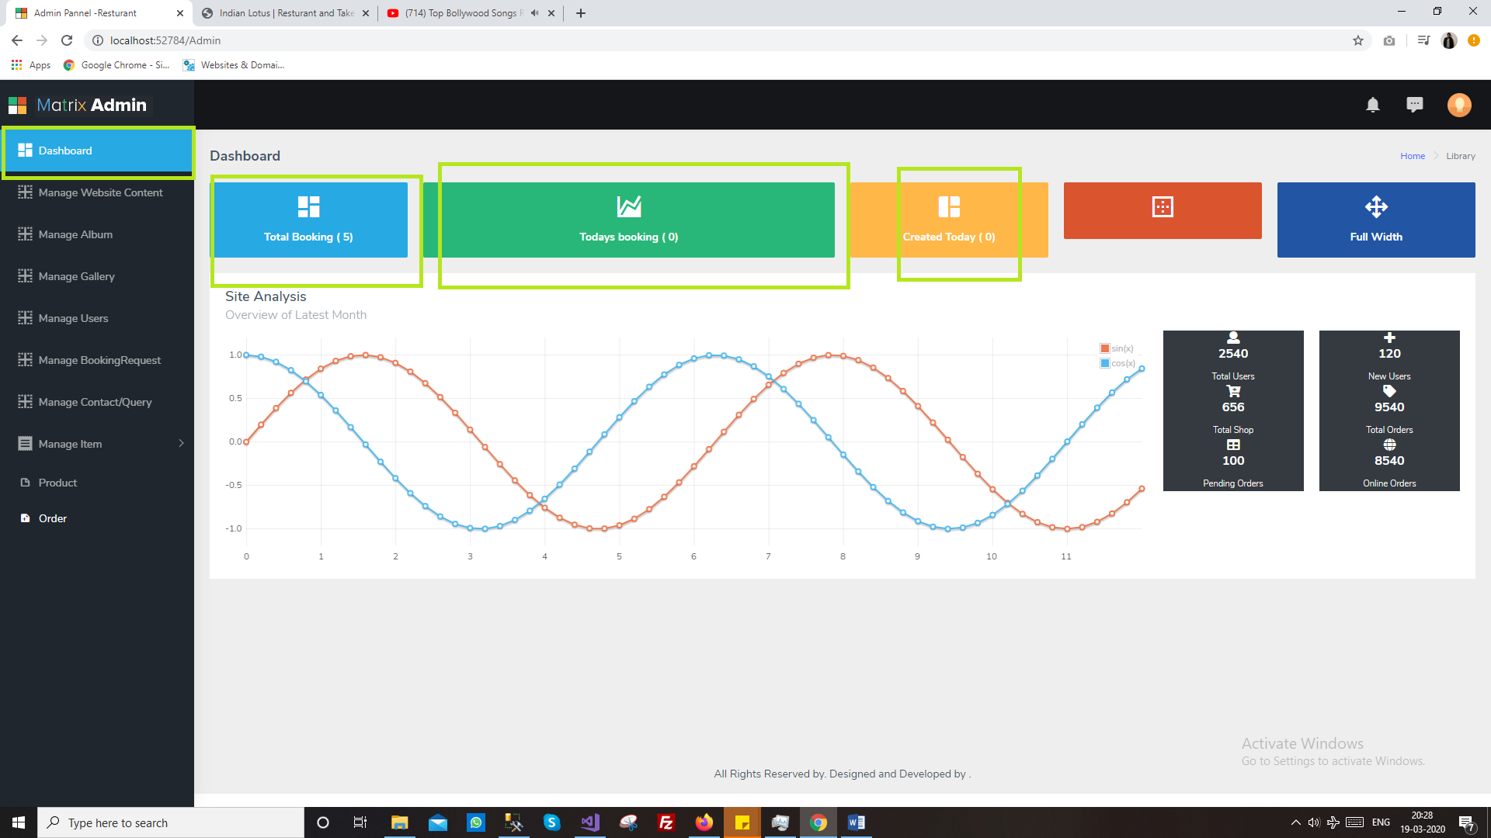

**3. User Module**

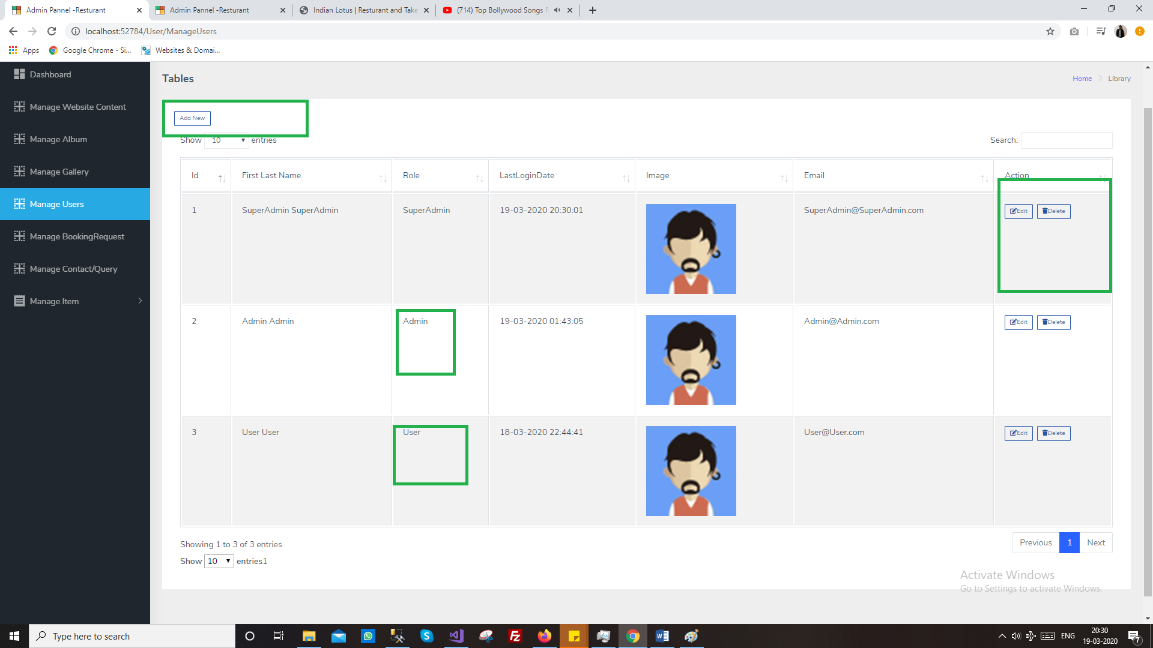

**4. Slider Item (Home page image)**

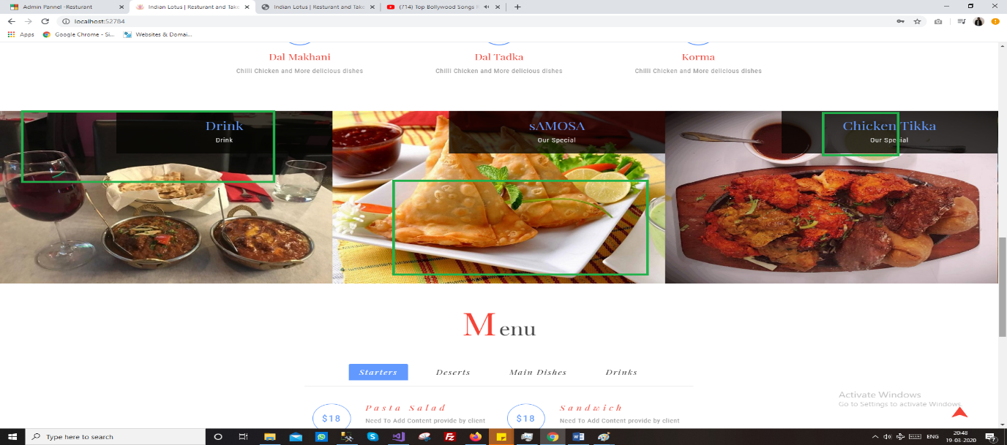

This screen will manage by admin to update from admin

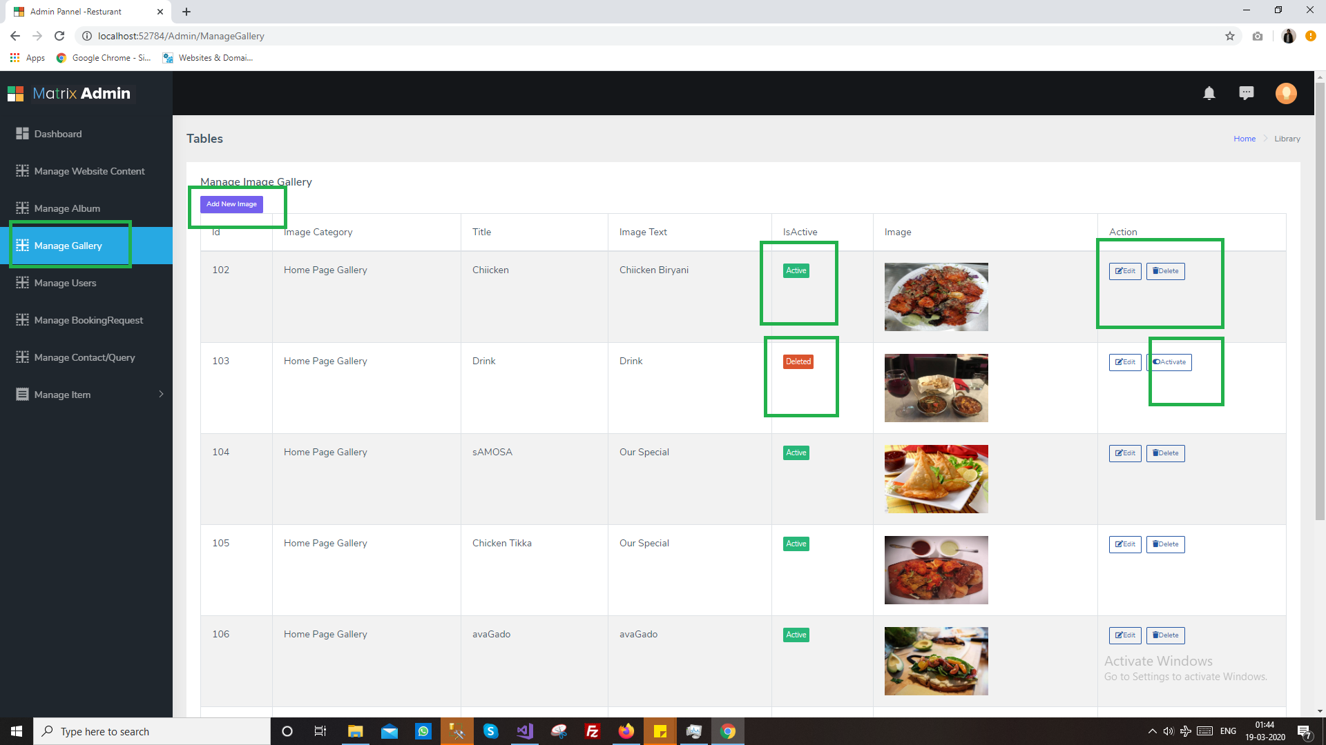

Edit/add screen for same

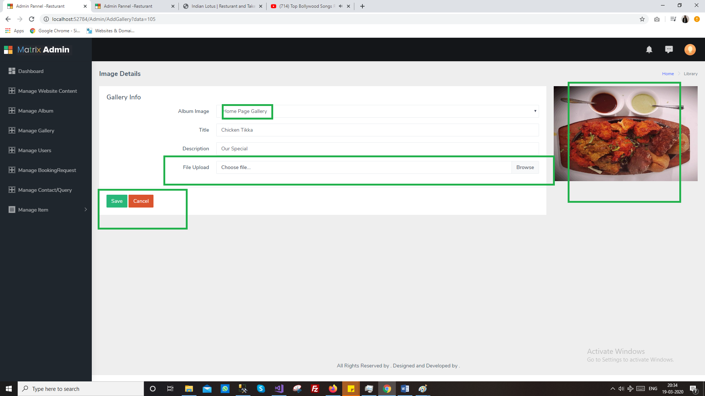

**5. Menu Item**

Manage item showing menus on home screen

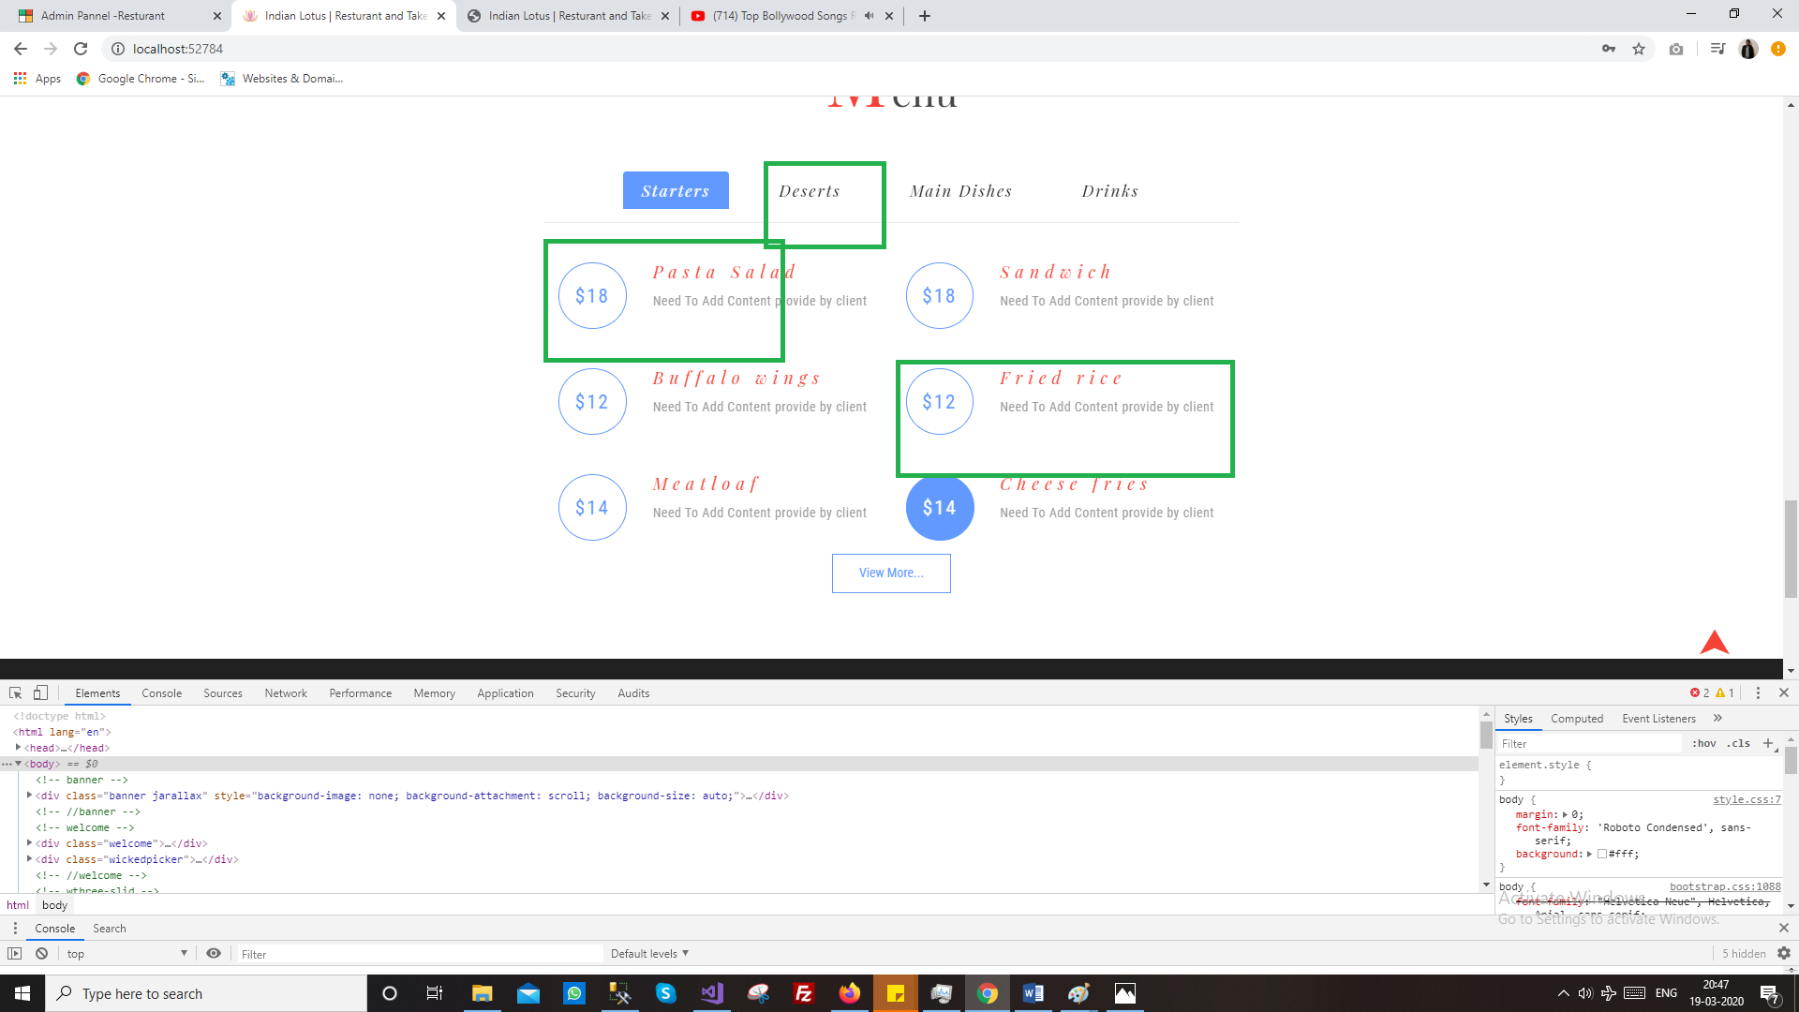

**6. Booking Module**

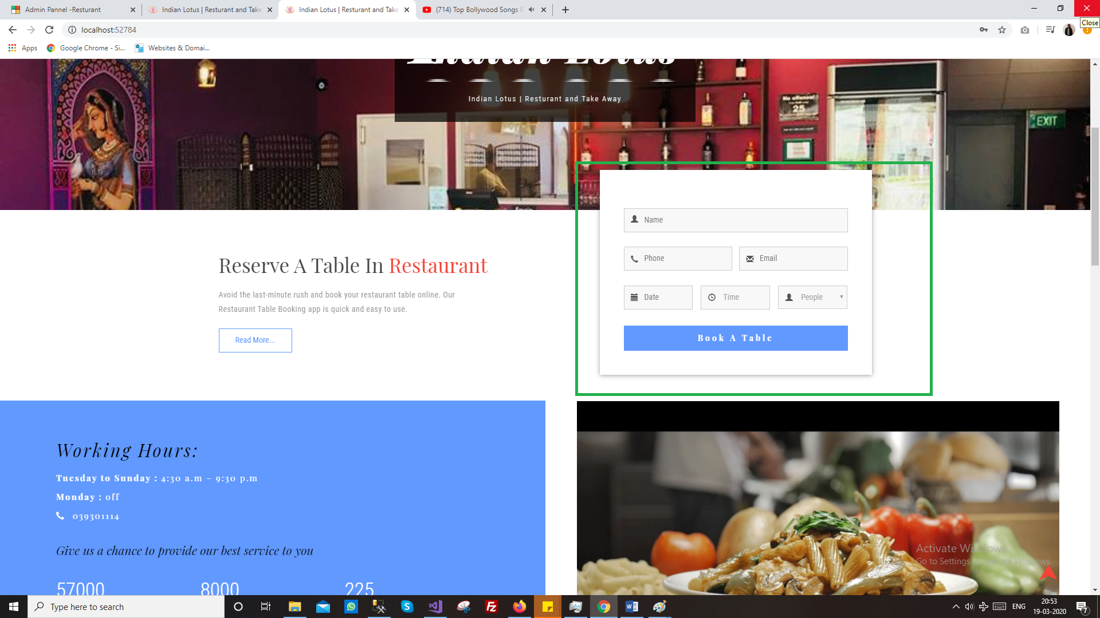

**Booking done by user can manage/view by user**

**Where user will get email on booking with desired template**

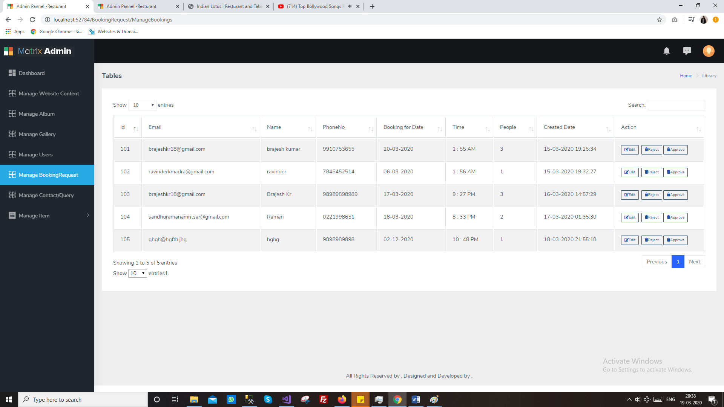

**7. Contact Request**

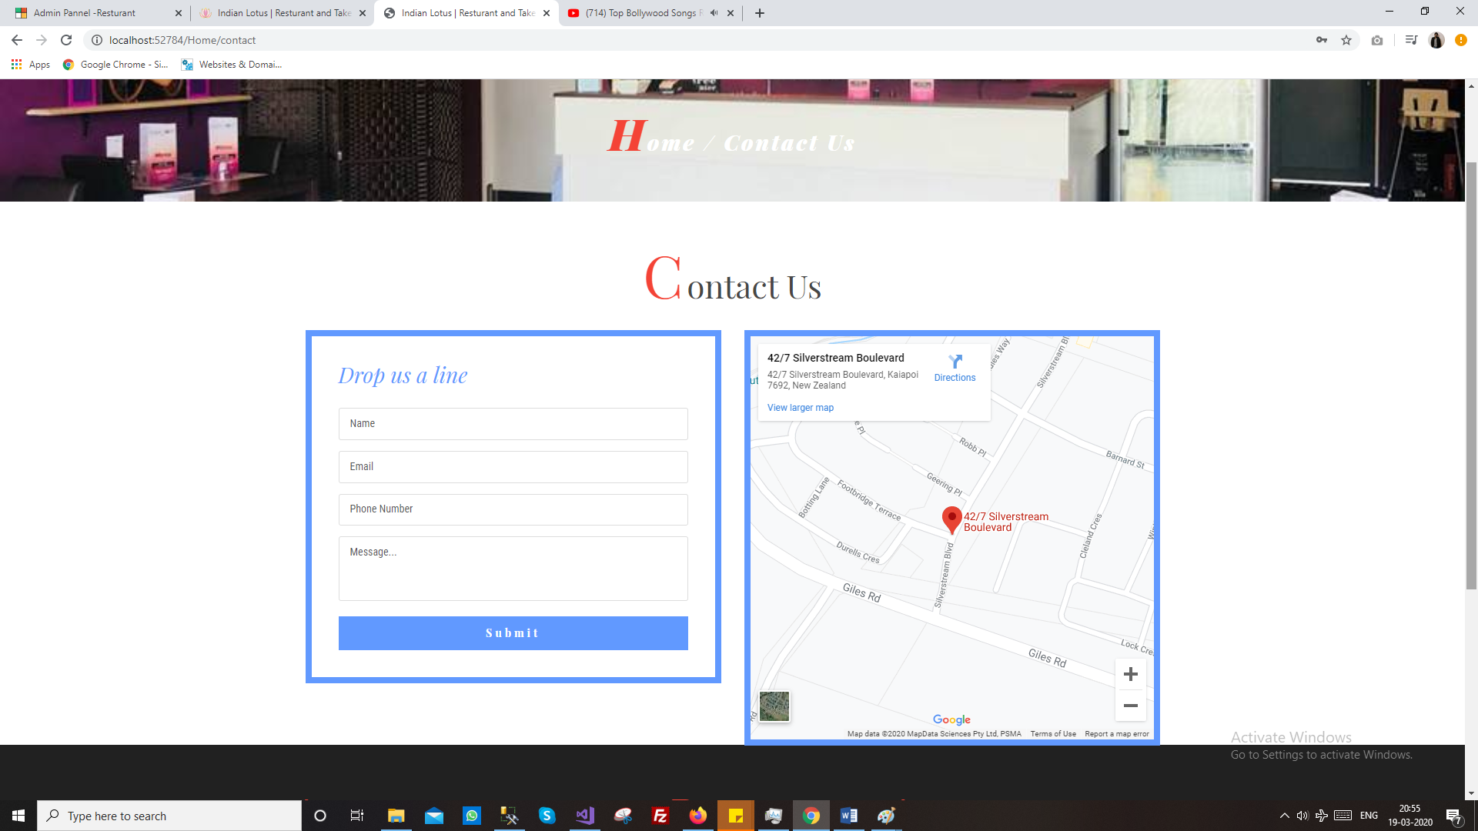

Manage contact requested by user

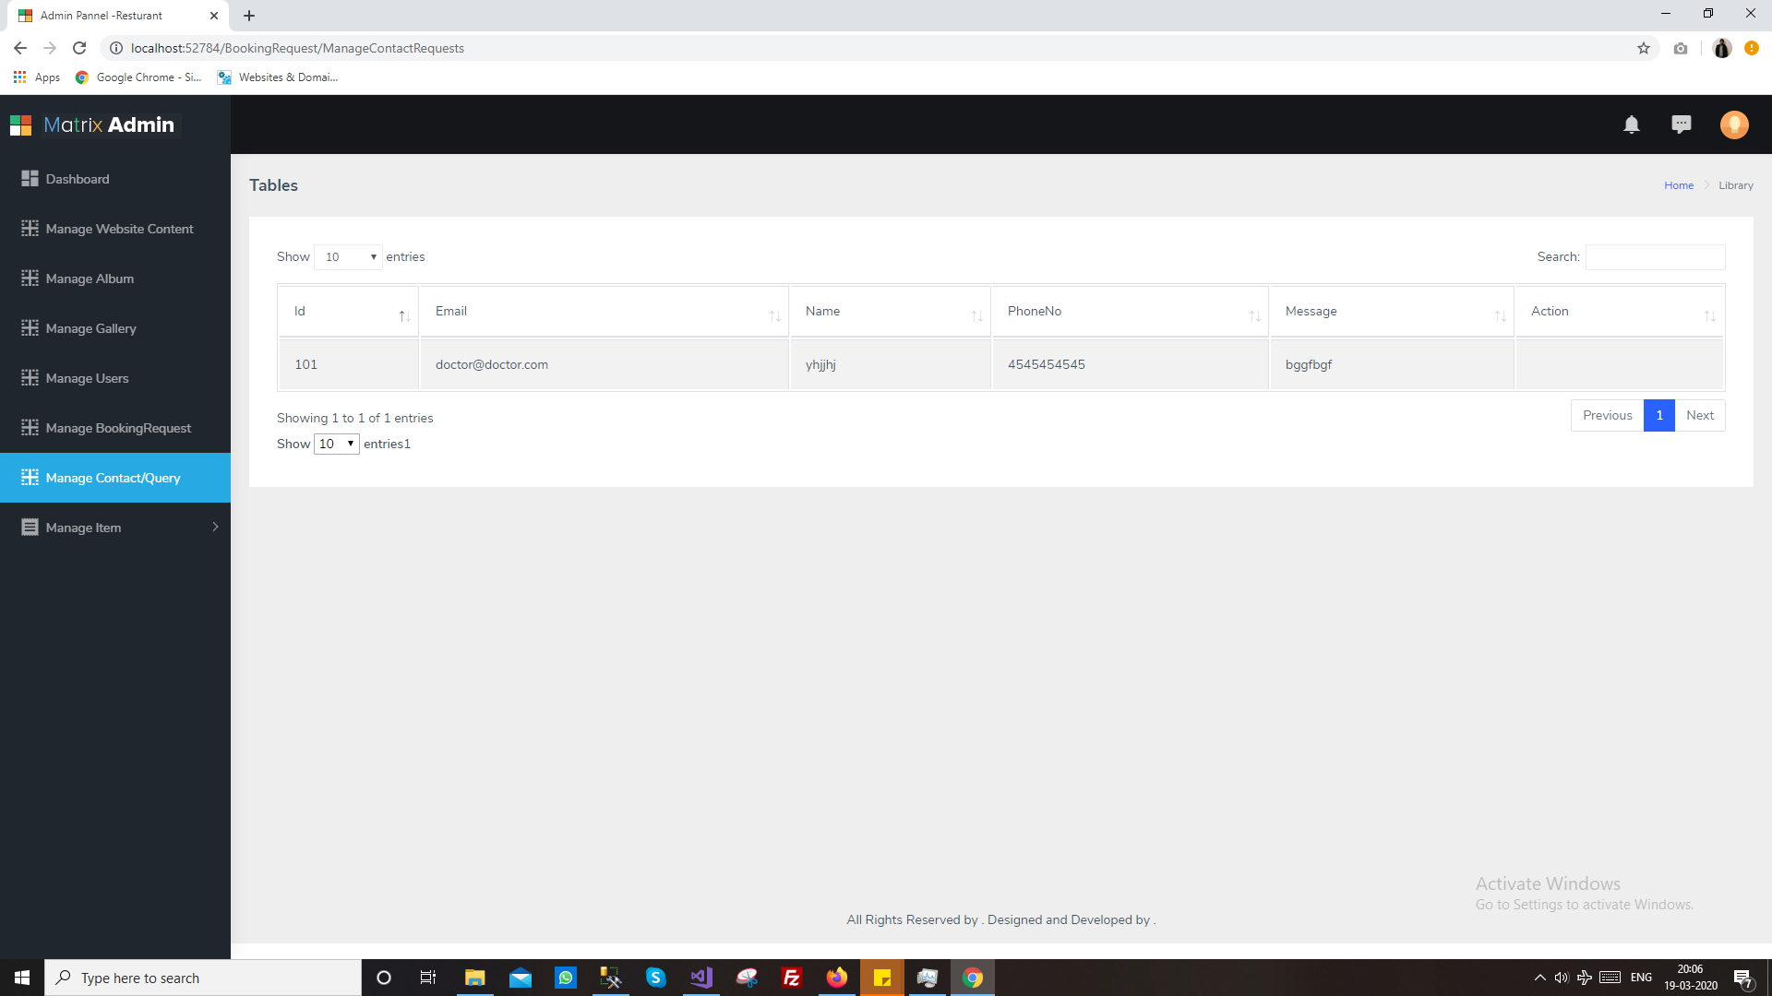

**8. Order**

Manage order generated by the user

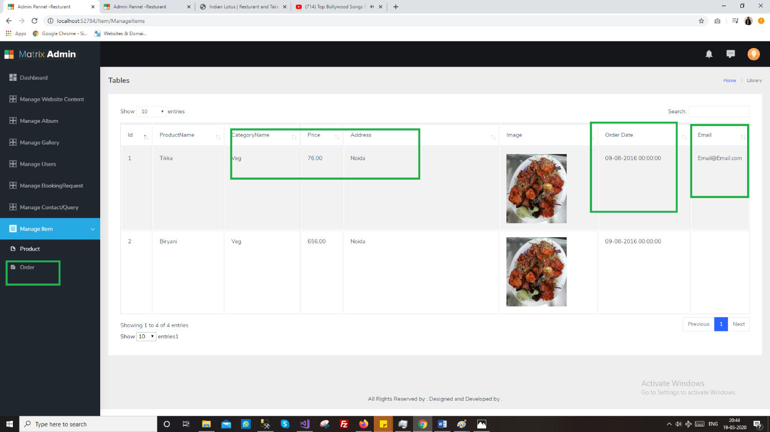

**9. Shipping/Delivery**

Get processed or in process item for delivery

**10. Product**

Add item/product with price ,image, and name with description

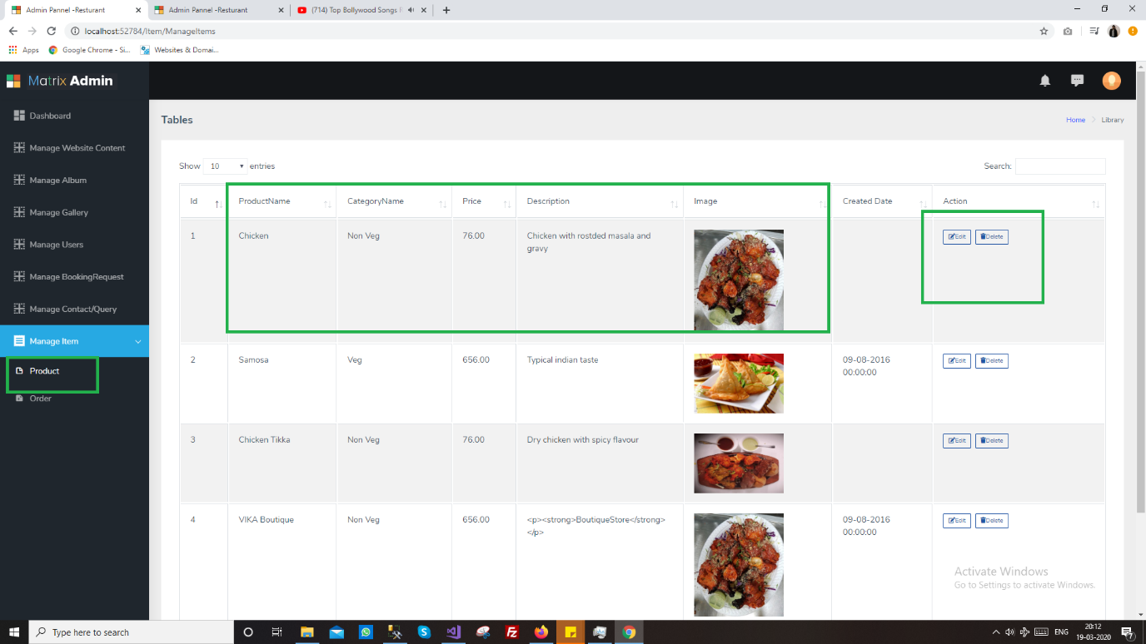

User

User will have access to the following modules

1. Login/ Register

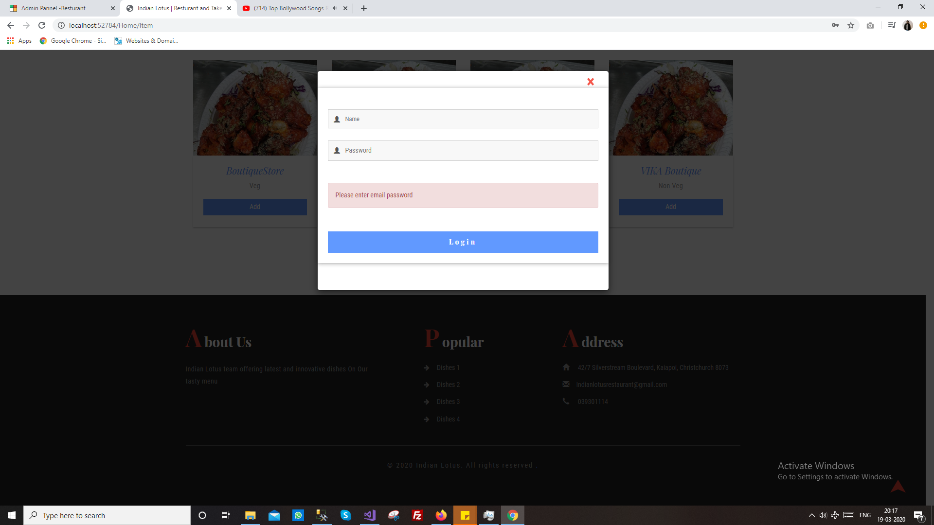

**2. My Order**

**3. Profile**

**4. Shipping Address**

**5. Book Table**



**6. Contact**

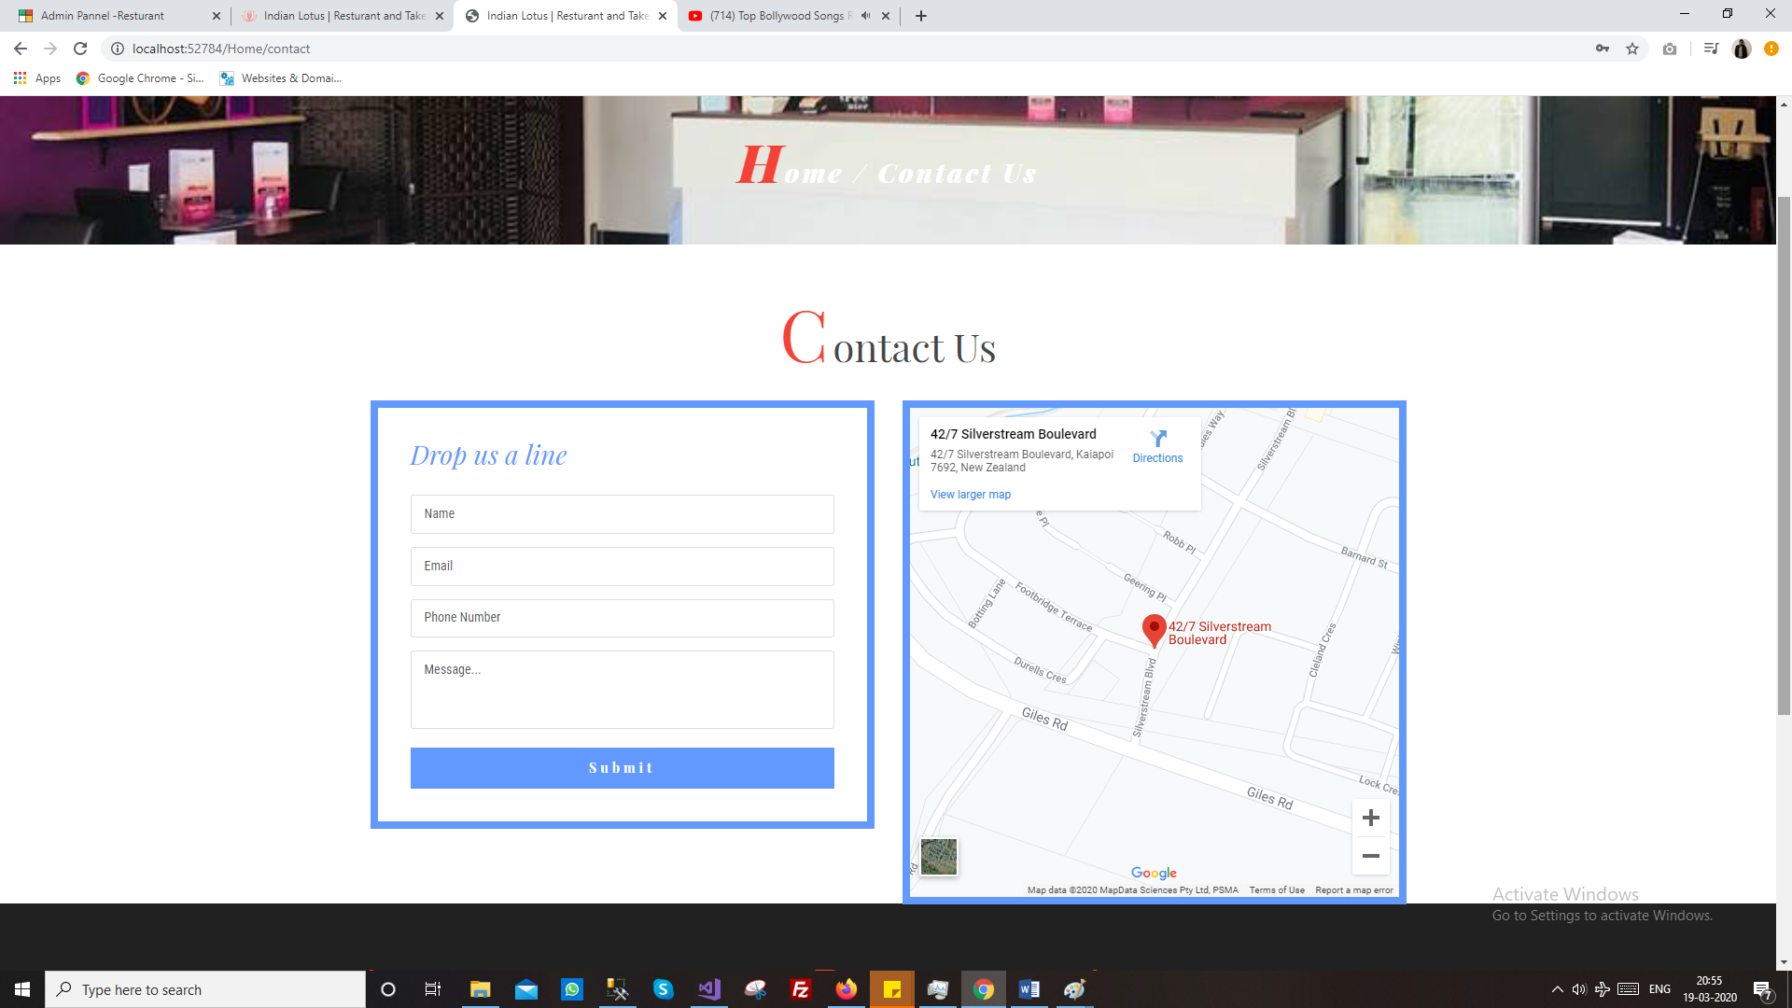

**7. Search Items**

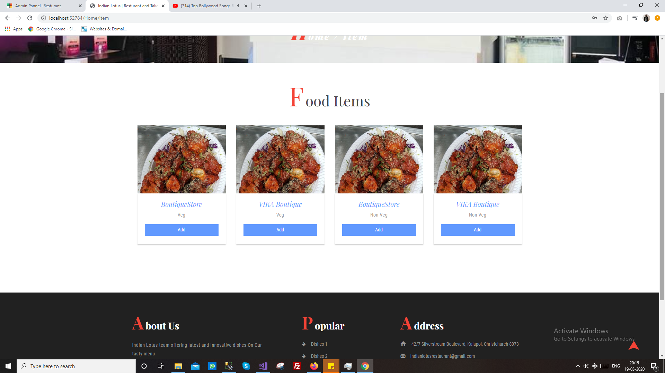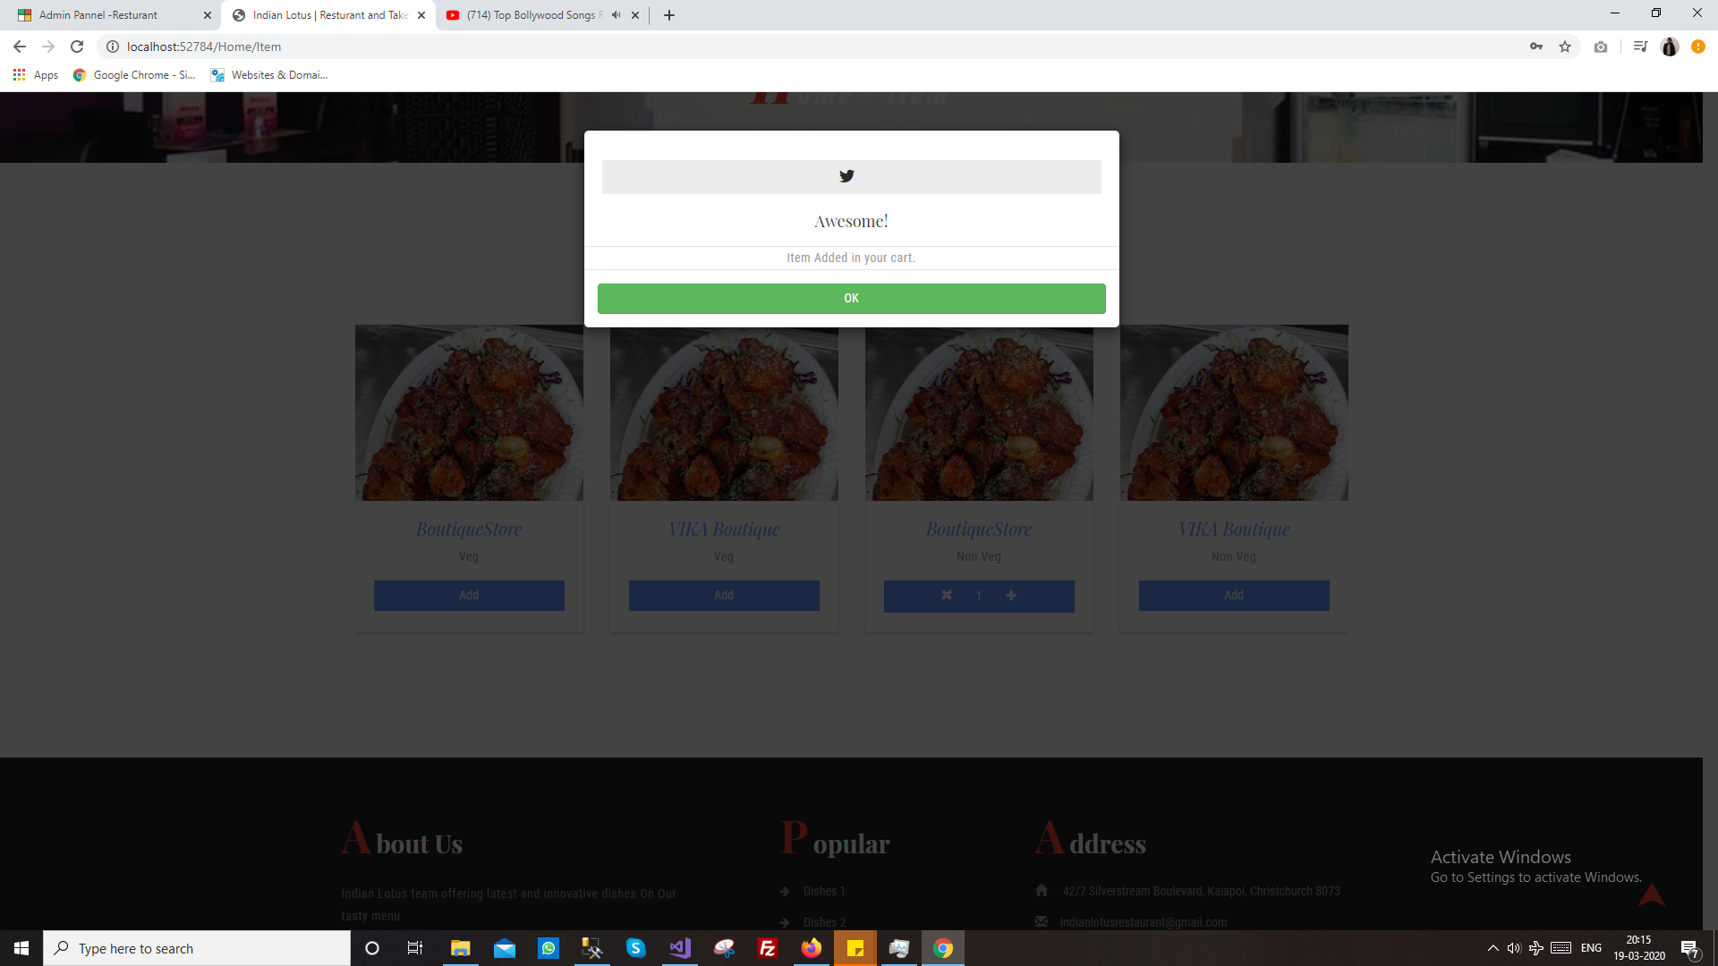

**8. Get email and notifications**

**9. All order will be pay on delivery**